**PURE MATHEMATICS 1 PAPER 1v2 WINTER 2021**

**TIME ALLOWED: 1 hour**

**ANSWER ALL THE QUESTIONS**

TOTAL MARKS = 41

**INSTRUCTIONS**: You can use a calculator.

You must show your method.

Answer all the questions.

You must make sure the work you present is yours and is not copied from somewhere else.

**Formulae**

$$a^{-n}=\frac{1}{a^{n}}$$

$$x=\frac{-b±\sqrt{b^{2}-4ac}}{2a}$$

**Questions**

1. Calculate  [3 marks]

$$2\frac{3}{5}+3\frac{2}{3}-4\frac{1}{4}$$.

1. A visitor to this country buys a bag costing £35.00 including VAT of 8%. How much VAT can be reclaimed? [4 marks]
2. Find the value of  [2 marks]
$$4×3^{2}-12÷3$$

3. Rationalise [2 marks]
$$\frac{2}{3-\sqrt{2}}$$

4. Write the equation using positive index. [2 marks]
$$4x^{-3}y^{2}$$

5. Expand [2 marks]
$$\left(3x-4\right)\left(x+2\right)$$

6. Expand the expression [3 marks]
$${\left(2m+n\right)}^{3}$$

7. Solve the quadratic equation for x; $3x^{2}-5x+1=0$

[3 marks]

*(Hint: use the quadratic formular)*

1. Solve the simultaneous equation [4 marks]
$$x+4y=10$$

$$3x+2y=5$$

2. Find the value of q in the figure below [2 marks]

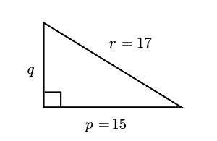

1. In the diagram below, find the height of the tower. [4 marks]

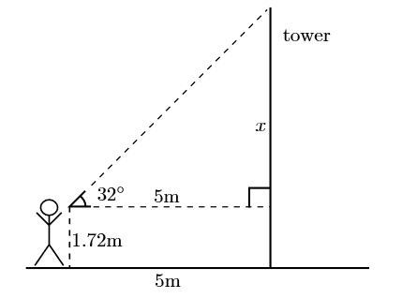

1. Convert [2 marks]
   1. 70 degrees to radian
   2. 1.3 radian to degrees
2. Determine all the angles between $0^{°}$ and ${360}^{°}$ whose cosine is (-0.8829). [4 marks]
3. Factorise the expressions [4 marks]

$x^{2}+3x+2$

$2x^{2}-x-6$